

**Monthly Business Update**

**April 2021**



**Coding Is Fun Corp.**

**Financial Highlights**

In the month of April we have generated 83829 USD.

|  |  |
| --- | --- |
| Top 3 Products | Sales in USD |
| Chairs | 14966 |
| Storage | 10201 |
| Phones | 9067 |

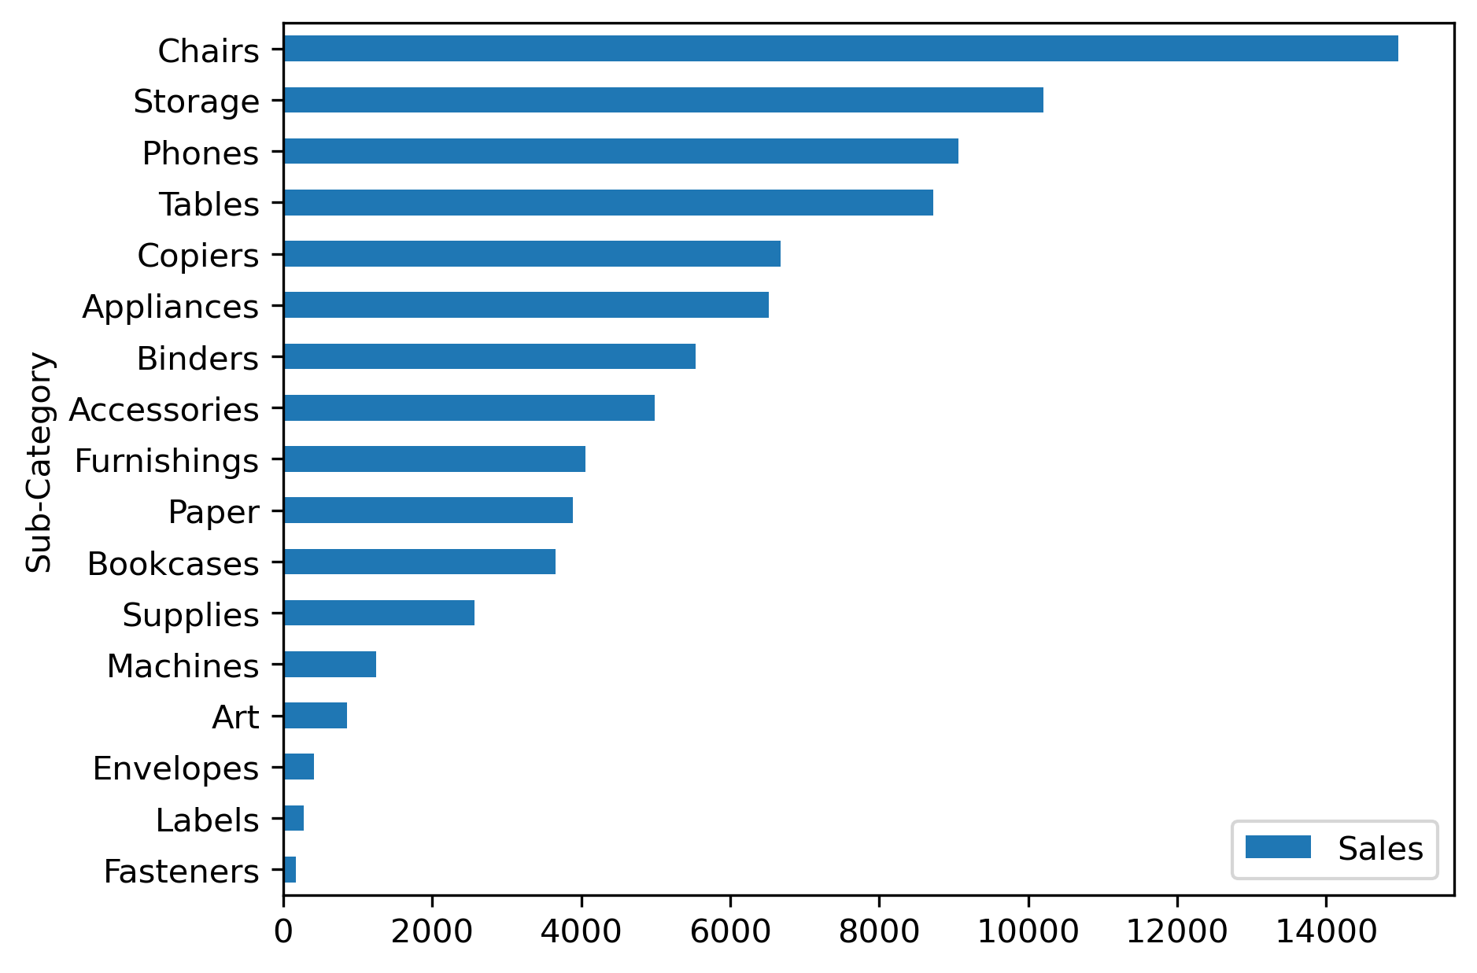**Sales by Products**